Pakistan Institute of Engineering and Applied Sciences

Department of Computer and Information Sciences

Bachelors of Sciences in Computer and Information Sciences

Project Report Template

Project Title

Simulating Traffic Prediction on Urban Road Network using Machine Learning



Student Name

M. HASEEB

RIMSHA AZMAT

Supervised by (Dr IRFAN UL HAQ)

**Table of Contents**

Contents

1. Introduction 3

2. Project Idea 4

3. Usefulness of the work 5

4. Related Work 6

5. SRS Details 7

6. DFDs and Other Related Diagrams 8

8. ProjectPlan 13

9. List of Deliverables 13

# Introduction

As urbanization accelerates, the challenges posed by traffic congestion in metropolitan areas become increasingly complex. The advent of smart technologies and machine learning presents a promising solution to address these challenges. This work focuses on developing a web application that leverages machine learning algorithms for simulating and predicting traffic patterns on urban road networks. The integration of advanced simulation tools, such as the Simulation of Urban Mobility (SUMO) simulator, with machine learning models marks a significant step towards creating a comprehensive solution for traffic management and prediction.

Urban traffic simulation has emerged as a critical tool for urban planners, transportation engineers, and researchers to analyze and optimize traffic flow. The ability to predict traffic conditions under various scenarios is invaluable for designing efficient transportation systems and alleviating congestion. The integration of machine learning into traffic simulation processes adds a layer of intelligence, allowing for dynamic predictions based on real-time data and historical patterns.

The web application developed in this work provides users with an interactive platform to create custom scenarios for traffic prediction simulations. Users can define a wide range of parameters, including traffic density, road configurations, vehicle types, and environmental conditions. The goal is to empower users, ranging from city planners to researchers, with a tool that facilitates the exploration of different scenarios and their potential impacts on urban traffic.

The SUMO simulator serves as the backbone of the simulation process. It is a widely used, open-source traffic simulation tool that can model complex urban road networks. By seamlessly integrating this simulator into the web application, users can initiate simulations of their custom scenarios with ease. The simulator's ability to consider factors such as traffic lights, intersections, and road layouts enhances the accuracy of the simulations, providing realistic results for subsequent analysis.

The machine learning component plays a pivotal role in predicting traffic patterns based on the simulated scenarios. By training on historical data and incorporating real-time information from the simulation, the machine learning model adapts to the dynamic nature of urban traffic. Users can compare the predicted results generated by the machine learning algorithm with the actual outcomes obtained from the SUMO simulator. This dual-approach evaluation offers a comprehensive view of the simulation results, enhancing the reliability and precision of the predictions.

Visualization is a key aspect of this web application, aiding users in interpreting the simulation results effectively. Graphs, charts, and maps provide an intuitive representation of traffic flow, congestion points, and potential bottlenecks. The real-time visualization during simulations enables users to monitor changes in traffic conditions as scenarios unfold, fostering a deeper understanding of the system dynamics.

The integration of machine learning with urban traffic simulation through a user-friendly web application represents a significant advancement in the field of traffic prediction. This work aims to contribute to the ongoing efforts in creating intelligent transportation systems, empowering decision-makers with tools to design and implement effective strategies for managing urban traffic congestion. The fusion of simulation technologies and machine learning holds the potential to revolutionize urban planning and transportation management, leading to more sustainable and efficient urban mobility solutions.

# Project Idea

The project revolves around the development of a user-friendly web application that integrates urban traffic simulation and machine learning for comprehensive traffic prediction on urban road networks. The aim is to provide urban planners, researchers, and transportation engineers with a powerful tool for creating custom scenarios and obtaining accurate predictions of traffic patterns in dynamic urban environments.

**Key Aspects of the Project:**

**User-Friendly Scenario Creation:**

The web application will feature an intuitive interface allowing users to create custom scenarios for traffic prediction simulations. Users can define various parameters such as traffic density, road configurations, vehicle types, and environmental conditions to tailor simulations to their specific needs.

**Integration with SUMO Simulator:**

Seamless integration with the Simulation of Urban MObility (SUMO) simulator will be a core component of the project. SUMO's robust simulation capabilities, including modeling traffic lights, intersections, and road layouts, will provide realistic and accurate results for analysis.

**Machine Learning for Prediction:**

The project incorporates machine learning algorithms to predict traffic patterns based on the simulated scenarios. By training on historical data and adapting to real-time information from simulations, the machine learning model enhances the accuracy and adaptability of traffic predictions.

**Dual-Approach Evaluation:**

Users will have the capability to compare predicted results generated by the machine learning algorithm with the actual outcomes obtained from the SUMO simulator. This dual-approach evaluation provides a comprehensive understanding of the simulation results, offering insights into the model's reliability and the simulator's accuracy.

**Educational and Decision-Making Tool:**

Beyond its technical aspects, the project aims to serve as an educational tool for users to gain insights into urban traffic dynamics. Additionally, it provides decision-makers with valuable information for designing and implementing effective strategies to manage and mitigate urban traffic congestion.

By combining the strengths of urban traffic simulation with machine learning, this project aspires to contribute to the advancement of intelligent transportation systems. The resulting web application will empower stakeholders with the tools they need to make informed decisions, optimize traffic management strategies, and work towards more sustainable and efficient urban mobility solutions.

# Usefulness of the work

The integration of urban traffic simulation with machine learning in the proposed web application holds significant importance due to its versatile applications and potential benefits for various stakeholders. The project's usefulness is underscored by its ability to address real-world challenges in urban mobility and offer valuable insights into traffic dynamics. Below are several

**key usages and benefits of this project:**

**Urban Planning and Design:**

The project provides urban planners with a powerful tool to simulate and analyze different traffic scenarios. This aids in designing more efficient road networks, optimizing traffic signal timings, and enhancing overall urban infrastructure planning.

**Traffic Management Strategies:**

Transportation authorities can use the web application to develop and assess traffic management strategies. By predicting traffic patterns under different conditions, authorities can implement dynamic traffic control measures to alleviate congestion and improve traffic flow.

**Infrastructure Optimization:**

The ability to simulate various scenarios helps in optimizing infrastructure investments. Decision-makers can evaluate the impact of new road constructions, modifications to existing roads, or changes in traffic regulations, ensuring cost-effective and efficient urban development.

**Public Safety and Emergency Response:**

Emergency response teams can benefit from the project by understanding potential traffic bottlenecks and optimizing routes during emergencies. This enhances the efficiency of emergency services and contributes to public safety.

**Environmental Impact Assessment:**

The project allows for the evaluation of the environmental impact of traffic patterns. By understanding how different scenarios affect emissions and air quality, environmentalists and policymakers can make informed decisions to promote sustainable urban development.

**Research and Development:**

Researchers in the field of transportation and urban studies can leverage the web application for experimentation and data analysis. The project provides a platform for testing, validating the models, and contributing to the advancement of knowledge in urban mobility.

**Education and Training:**

The web application serves as an educational tool, offering students and professionals an interactive platform to learn about urban traffic dynamics. It can be integrated into academic curricula and training programs to enhance understanding and skills in traffic simulation and machine learning.

**Data-Driven Decision-Making:**

Decision-makers at various levels can make data-driven decisions based on the insights gained from the simulations. This ensures that policies and interventions are grounded in empirical data, leading to more effective and evidence-based urban planning.

**Community Engagement:**

By visualizing and explaining the results of traffic simulations, the project fosters community engagement. Residents and stakeholders can better understand the implications of proposed changes, encouraging collaboration and constructive input in the decision-making process.

Efficient Resource Allocation:

# Related Work

In the dynamic field of urban traffic simulation and machine learning applications, numerous significant works and tools have contributed to the understanding and resolution of challenges in this domain. Below, we delve into more detailed references and related efforts, shedding light on specific research studies and open-source projects that play a pivotal role in shaping the integration of these technologies:

**Simulation Platforms:**

**SUMO (Simulation of Urban Mobility):**

SUMO stands out as a prominent open-source traffic simulation platform, allowing for the modeling of intricate urban traffic scenarios. It supports the simulation of various traffic elements, including traffic lights, intersections, and road networks, making it a versatile tool.

Website: SUMO

**AIMSUN:**

AIMSUN is a comprehensive simulation platform designed specifically for traffic modeling and analysis. It facilitates the simulation of large-scale transportation networks and is often employed to assess the impact of urban planning decisions on traffic flow dynamics.

Website: AIMSUN

**Machine Learning in Traffic Prediction:**

**TensorFlow and PyTorch:**

TensorFlow and PyTorch, being two of the most widely used open-source machine learning frameworks, offer an extensive suite of tools and algorithms suitable for traffic prediction tasks. They empower developers to construct and train predictive models effectively.

Websites: TensorFlow, PyTorch

Traffic Prediction Research:

"Traffic Flow Prediction with Big Data: A Deep Learning Approach" (Z. Zheng et al., IEEE Transactions on Intelligent Transportation Systems) explores the application of deep learning, specifically Long Short-Term Memory (LSTM) networks, in predicting traffic flow. This work showcases the potential of sophisticated neural network architectures in enhancing prediction accuracy.

"Short-Term Traffic Flow Prediction: An Experimental Comparison of Time-Series Analysis and Recurrent Neural Networks" (S. L. Smith et al., Transportation Research Part C) provides valuable insights by comparing traditional time-series analysis methods with Recurrent Neural Networks (RNNs) for short-term traffic flow prediction.

**Open-Source Projects:**

**CityFlow:**

CityFlow, an open-source project, takes a hybrid approach by combining macroscopic and microscopic traffic modeling. It focuses on efficiently simulating large-scale urban road networks and provides a flexible platform for experimentation.

GitHub: CityFlow

**OpenTraffic:**

OpenTraffic, an open-source initiative, offers access to real-time traffic data through APIs and tools. It serves as a valuable resource for developers working on traffic-related projects, providing real-time data to enhance the accuracy of traffic prediction models.

GitHub: OpenTraffic

**Additional Research Studies:**

Title: "Deep Spatiotemporal Residual Networks for Citywide Crowd Flows Prediction"

Authors: X. Zhang, J. Zheng, and Y. Ma

Published in: Proceedings of the AAAI Conference on Artificial Intelligence

This research delves into the use of deep spatiotemporal residual networks for predicting citywide crowd flows, showcasing the application of advanced neural network architectures in urban mobility studies.

These detailed references and projects provide a more comprehensive understanding of the landscape in the intersection of urban traffic simulation and machine learning. Continuous literature reviews are integral to staying abreast of the latest developments, methodologies, and emerging tools, ensuring that our project aligns with the forefront of advancements in this dynamic field.

# SRS Details

SRS attached with report.

# DFDs and Other Related Diagrams

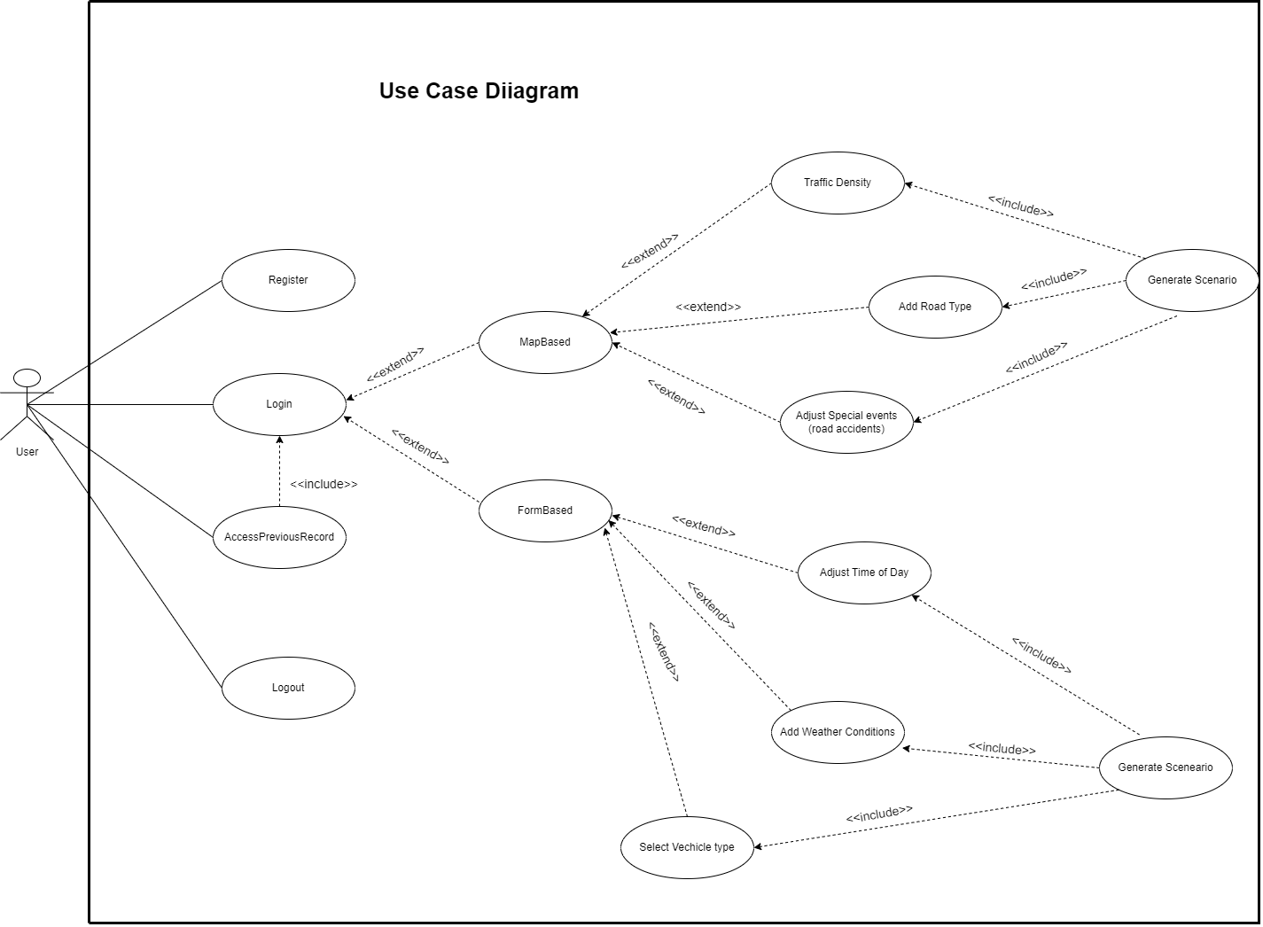

Figure Use Case Diagram

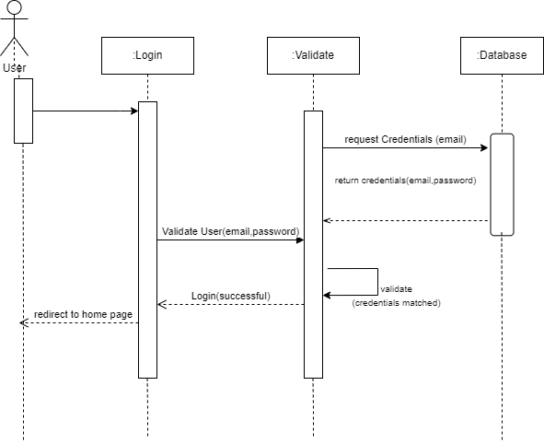

Figure Log In Sequence Diagram

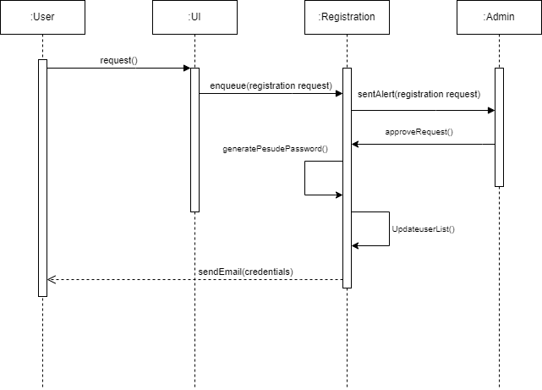

Figure Registration Sequence Diagram

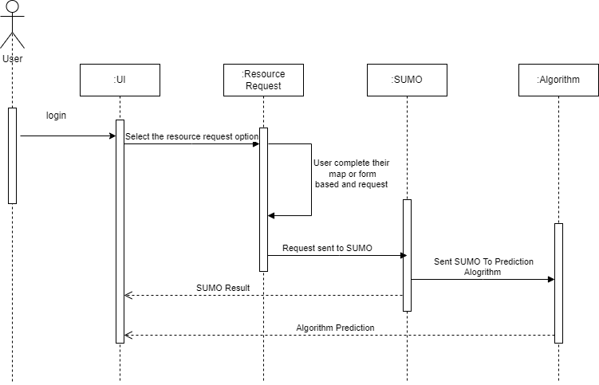

Figure Results Sequence Diagram

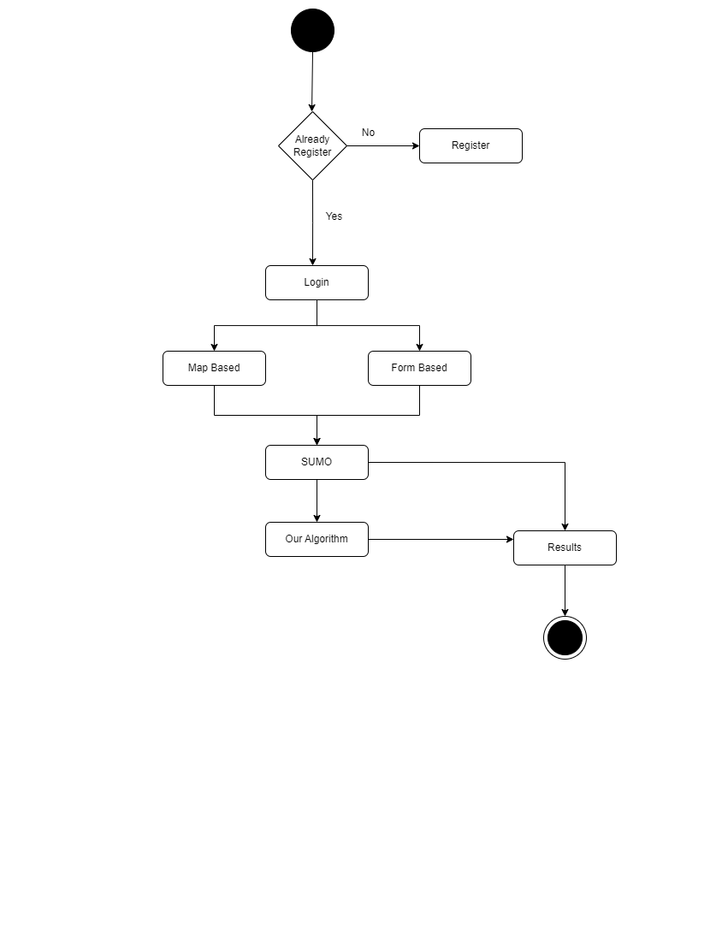

Figure Activity Diagram

# ProjectPlan

This is an abstract plan or major plan, student should discuss with supervisor to mark major activities and milestones of the project along with an estimation of time required to complete these activities/milestones. The plan will help students to stay focus, will let the supervisor to monitor the progress and will facilitate the evaluators to evaluate on the basis of planned activities.

|  |  |  |
| --- | --- | --- |
| **Sr. No** | **Milestone** | **Expected Date of Completion** |
| 1 | Literature Review (Research Papers) | February 2024 |
| 2 | OSM Based SUMO Simulations | December 2023 |
| 3 | Test Algorithm Development | January 2024 |
| 4 | Synthetic Traffic Generation on SUMO and Integrating Test Algorithm | February 2024 |
| 5 | Analyzing the Results of Test Algorithm on Synthetic Traffic | February 2024 |
| 6 | Final Algorithm Development | April 2024 |
| 7 | Testing of Final Algorithm | April 2024 |
| 8 | Web Application Development | May 2024 |
| 9 | Testing of Web Application | May 2024 |
| 10 | Testing of Complete System at Once | May 2024 |
| 11 | Thesis writing Completion | May 2024 |

# List of Deliverables

The list of deliverables for your Traffic Simulation Web Application project may include:

**Project Proposal:**

A comprehensive document outlining the project scope, objectives, methodology, and expected outcomes.

**System Requirements Specification (SRS):**

A detailed document specifying the functional and non-functional requirements of the web application.

**System Design Document:**

Comprehensive documentation detailing the architectural and design aspects of the web application, including database schema, user interface design, and system flow.

**User Interface (UI) Prototypes:**

Mockups or interactive prototypes showcasing the visual design and user interface of the web application.

**Database Schema:**

A detailed representation of the database structure, including tables, relationships, and data types.

**Source Code:**

The actual codebase of the web application, organized and documented for ease of understanding and future development.

**Web Application:**

The deployed and fully functional web application accessible through a web browser.

**Simulation Results:**

Reports or visualizations generated from the traffic simulations performed by the application.

**Machine Learning Model:**

The trained machine learning model(s) used for traffic predictions, along with documentation on model architecture and usage.

**User Documentation:**

Comprehensive guides and manuals to help users understand how to use the application effectively.

**Administrator Documentation:**

Guides for administrators detailing how to manage, monitor, and maintain the web application.

**Testing Documentation:**

Reports and documentation related to the testing process, including test plans, test cases, and results.

**Deployment Documentation:**

Instructions for deploying the web application in different environments, including any dependencies or configurations.

**Training Materials:**

Educational materials for users and administrators to facilitate the understanding and usage of the application.

**Project Report:**

A detailed report summarizing the project, including its objectives, methodologies, challenges, and outcomes.

**Project Presentation:**

A visual presentation summarizing key aspects of the project, suitable for stakeholder meetings or project reviews.

**Maintenance and Support Plan:**

A plan outlining how ongoing maintenance and support for the web application will be handled post-deployment.

**Project Evaluation:**

An evaluation report assessing the success of the project in meeting its objectives and addressing any lessons learned for future projects.